Case Study

Casting Doubt over Future of the Paralympics
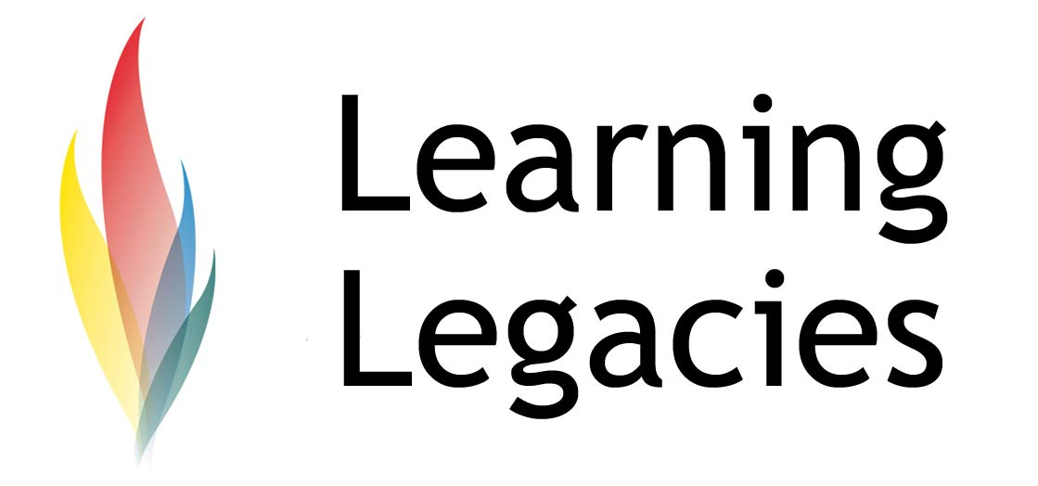

The commercialisation of the Olympic Games has remained a primary topic of conversation since the great financial success fo the LA Games in 1984. At the time, the Games were a great success in terms of securing the future of the Movement, due to the financial restructuring of the way in which the Games were financed. The restructuring and commercialisation of the event followed the significant economic difficulties of the Montreal 1986 Games that saw Montreal residents pick up a massive bill that was not paid off until the 2000’s.

A great debate still exists regarding the commercialization of the Olympic Games. Some argue that such an efficient commercial model is crucially important for safeguarding the future success of the Olympic Movement. Others are critical of the approach, as they feel that the need to generate profits has far outweighed the central importance of the intrinsic value of amateur sport.

THE PARALYMPIC GAMES 2018

The most significant source of funding for the IOC (and, indeed, for many sports) is the sale of media rights. Negotiations of these rights form a pivotal part of generation of revenue for successive Games.

However, arguments over media rights have threatened to overshadow, and even jeopardise forthcoming games – most specifically, the 2016 Paralympic Games. Negotiations between the International Olympic Committee and the International Paralympic Committee have covered many months,

and disagreements centre around control of media rights and marketing. Recently, the International Olympic Committee withdrew the contract for signing for the hosting of the 2018 Winter Paralympic Games from Pyeongchang. Pyeongchang has won the rights to stage the Winter Olympics. Whilst it is de rigeur for host cities to sign contracts for hosting the Olympic and Paralympic Games immediately after the announcement of their successful bid, this has not been the case for Pyeongchang – only the Olympic bid contract was signed. This means that, currently, the 2018 Paralympic Games do not have a host city within which the Games can take place. South Korean IPC board member Hyang-Sook Jang commented that: ‘'We might not see a Paralympic Games in Pyeongchang in 2018”.

The reason for the withdrawal of the contract for signing is based solely on the complex negotiations that had taken place with regard to the marketing, broadcasting and commercial aspects of the Paralympics. The argument is based on the fact that the IOC contributes around £1.26m ($2 million) a year to help fund the Paralympics Movement. The IOC has recently offered to increase the annual subsidy by 50%, in return for greater control over the staging of the Paralympic Games. This would effectively give the IOC the rights to manage the Paralympic Games immediately after the Olympic Games have taken place. This would notionally allow the IPC to focus on the development of grassroots and elite pathways for disabled athletes to enable the growth of Paralympic level sport, and to further enable opportunities for athletes.

Although the Paralympic Games have increased in popularity over the last few Games, with host cities (most recently Beijing) hosting ever bigger and better Games, the Paralympic Movement continues to face funding difficulties. Currently, the 2012 London Paralympic Games receive £80 million of funding from the taxpayer, but this does not meet all the costs of operation. The London operating budget currently stands at a combined Olympic and Paralympic budget of £2.15 billion.

FUNDING & THE FINANCIAL CRISIS

The inevitable pressure on host nations to commit significant funds to the development of facilities, hosting the Games, increasing security, developing transportation links, and all other related costs have led to a strain on the taxpayer, who are required to foot the bill for the Games via taxation. Following the financial crisis of 2008, sparked by excess liquidity in global markets and the subprime mortgage crisis that originated in the US, many nations are unable to commit funds to major sporting events such as the Olympic and Paralympic Games, or to the honouring of legacy promises in their entirety (as may be the case for LOCOG and the London 2012 Games). This may lead to a global shift in terms of the nations that are prepared to, or are capable to, bid for the Games over the coming years. It might also contribute to a ‘downsizing’ of the scale or financial commitment made to the promises attached to hosting the Games in future years.

SUMMARY

Case Study

Casting Doubt over Future of the Paralympics

Casting Doubt over Future of the ParalympicsWOMENS PARTICIPATION IN THE OLYMPIC GAMES
It is likely that the IOC and IPC will reach an amiable agreement over the negotiations surrounding marketing and media rights. It is extremely unlikely that the future of the 2018 Winter Paralympic Games would be put in jeopardy; however, the fact that negotiations over the host city contractual signing of the Games continue to take place in a protracted way signals the central importance of financial concerns to the Games and to global sport.
FURTHER INFORMATION
- Commercialisation of the Games:
http://www.heacademy.ac.uk/assets/hlst/documents/olympic_sig/discussion_starters/DS18-Commercialisation-of-the-Games.pdf

- The commercialization of the Olympics: Cities, corporations and the Olympic commodity: http://alantomlinson.typepad.com/alan_tomlinson/files/Tomlinson_YoungBook.pdf

DISCUSSION
- The Games in their present form could not exist without a commitment to maximisation of profit and revenue. Do you feel that the benefits of commercialisation outweigh the negative connotations associated with it?
- How has LOCOG utilised the benefits of commercialisation to generate profit from the 2012 Games?
- What threats currently exist to this profit maximisation? Consider macro and micro economic forces in your answer.

Case Study

Casting Doubt over Future of the Paralympics

WOMENS PARTICIPATION IN THE OLYMPIC GAMES
This resource was produced as part of the 2012 Learning Legacies Project managed by the HEA Hospitality, Leisure, Sport and Tourism Subject Centre at Oxford Brookes University and was released as an Open Educational Resource. The project was funded by HEFCE and part of the JISC/HE Academy UKOER programme. Except where otherwise noted above and below, this work is released under a Creative Commons Attribution only licence.

Exceptions to the Licence
The name of Oxford Brookes University and the Oxford Brookes University logo are the name and registered marks of Oxford Brookes University. To the fullest extent permitted by law Oxford Brookes University reserves all its rights in its name and marks, which may not be used except with its written permission. The JISC logo is licensed under the terms of the Creative Commons Attribution-Non-Commercial-No Derivative Works 2.0 UK: England & Wales Licence. All reproductions must comply with the terms of that licence.

The Higher Education Academy logo is owned by the Higher Education Academy Limited and may be freely distributed and copied for educational purposes only, provided that appropriate acknowledgement is given to the Higher Education Academy as the copyright holder and original publisher.

Reusing this work
To refer to or reuse parts of this work please include the copyright notice above including the serial number. The only exception is if you intend to only reuse a part of the work with its own specific copyright notice, in which case cite that.

If you create a new piece of work based on the original (at least in part), it will help other users to find your work if you modify and reuse this serial number. When you reuse this work, edit the serial number by choosing 3 letters to start (your initials or institutional code are good examples), change the date section (between the colons) to your creation date in ddmmyy format and retain the last 5 digits from the original serial number. Make the new serial number your copyright declaration or add it to an existing one, e.g. ‘abc:101011:011cs’.

If you create a new piece of work or do not wish to link a new work with any existing materials contained within, a new code should be created. Choose your own 3-letter code, add the creation date and search as below on Google with a plus sign at the start, e.g. ‘+tom:030504’. If nothing comes back citing this code then add a new 5-letter code of your choice to the end, e.g.; ‘:01lex’, and do a final search for the whole code. If the search returns a positive result, make up a new 5-letter code and try again. Add the new code your copyright declaration or add it to an existing one.

